DELIMITER $$

CREATE FUNCTION CustomerLevel(p_creditLimit double) RETURNS VARCHAR(10)

    DETERMINISTIC

BEGIN

    DECLARE lvl varchar(10);

    IF p_creditLimit > 50000 THEN

SET lvl = 'PLATINUM';

    ELSEIF (p_creditLimit <= 50000 AND p_creditLimit >= 10000) THEN

        SET lvl = 'GOLD';

    ELSEIF p_creditLimit < 10000 THEN

        SET lvl = 'SILVER';

    END IF;

RETURN (lvl);

END

Output

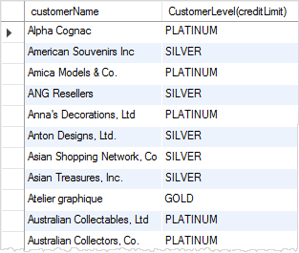

DBMS_OUTPUT PACKAGE FOR MARIADB

An Oracle database contains over [200 PL/SQL packages](https://docs.oracle.com/database/121/ARPLS/toc.htm). One of the most common one is the [DBMS_OUTPUT package](https://docs.oracle.com/database/121/ARPLS/d_output.htm#ARPLS67300). In this package we can find the Procedure [PUT_LINE](https://docs.oracle.com/database/121/ARPLS/d_output.htm#ARPLS67327).

This package/function has not been implemented yet by MariaDB so far. So we have to do it ourself:

DELIMITER /

CREATE OR REPLACE PACKAGE DBMS_OUTPUT AS

PROCEDURE PUT_LINE(pString IN VARCHAR2);

END DBMS_OUTPUT;

/

CREATE OR REPLACE PACKAGE BODY DBMS_OUTPUT AS

PROCEDURE PUT_LINE(pString IN VARCHAR2) AS

BEGIN

SELECT pString;

END;

END DBMS_OUTPUT;

/

BEGIN

DBMS_OUTPUT.PUT_LINE('Hello world from MariaDB DBMS_OUTPUT.PUT_LINE!');

END;

/

DELIMITER ;